***Project Handover Document***

***Company ----Redback Operations***

***Project -----VR Sun cycle***

***Trimester 1, 2023***

**1. Project information** **2**

1.1 Company Acting Director 2

1.2. Project Team 2

1.3. Members 2

**2. Project Overview** **3**

3. User Manual 3

3.1. Microsoft Teams 3

3.1.1. Communication 3

3.1.2. File Storage 4

3.2. Trello 5

3.3. Unity (Editor Version: 2020.3.37f1) 11

3.3.1 Installation and setup 11

3.3.2. Basics of Unity 15

3.3.3 Build settings 18

3.3.4. Using VR Headset 20

3.4. GitHub 21

3.4.1. Setup Github 22

3.4.2. Using GitHub with Unity 31

3.5. Blender / Maya / 3D Max 37

3.5.1 Installation and setup 3DMAX 37

**4. Deliverables** **41**

**5. Open Issues** **41**

**6. Lessons Learned** **42**

**7. Product Development Life Cycle** **44**

1. New Tasks 44

2. Definition of Done 44

3. Task Review 44

**4. Testing** **44**

5. Branching Strategy 45

**8. Product Architecture** **45**

1. UML Diagram 45

2. Tech Stack 46

**9. Appendices** **47**

9.1 Showcase Video 47

9.2 Documentation Deliverables 47

9.3 unity Deliverables 48

**10. Content Contribution** **53**

# **Project information**

## **1.1 Company Acting Director**

Kevin Lee

Director

[kevin.lee@deakin.edu.au](mailto:kevin.lee@deakin.edu.au)

## **1.2. Project Team**

Company: Redback Operations

Team: Virtual Reality

Channel: VR modelling and World Building Hub

Project: Sun Cycle

## **1.3. Members**

| Name | Senior/Junior/Position | Role |
| --- | --- | --- |
| Daniel Isla | Junior - Regular Member | Game Engine/Programming |
| Hilal Irshad | Junior - Team Lead | Game Engine/Programming |
| Jiahao Feng | Senior - Regular Member | Design/Asset Creation |
| Nathan James Fairchild | Junior - Regular Member | Design/Asset Creation / Game Engine/Programming |
| Steven Makris | Junior - Regular Member | Design/Asset Creation / Game Engine/Programming |

# Project Overview

Project Sun Cycle is a Virtual Reality based game which is played in combination with an exercise bike. In this single player experience the player is able to explore and travel across the post-apocalyptic tribal world completing quest such as delivering goods between the different tribes on their hover skater-bike. The aim of this project is to create a fun and immersive experience that will encourage people to exercise more with the increased motivation of being able to play a video game simultaneously.

An overall goal of incorporating enjoyable yet challenging quests within the game will help test the endurance/strength of the players and keep them exercising on a regular basis. Another aspect of this is incorporating a beautiful in game environment to visually impress the player as they travel around the game world.

In conclusion as stated above this project aims to solve the problem of low motivation to exercise by gamifying an otherwise boring workout.

## **User Manual**

## **3.1. Microsoft Teams**

Once added to the Redback Operations Company use the “VR Modelling and World Building Hub” public channel for communication and file storage.

## **3.1.1. Communication**

Communicate with your team using posts, personal messages and making sure to engage in scheduled meetings to have discussions about the project.

## **3.1.2. File Storage**

Store any contributes, ideas and important files within the files section of the channel. Make sure to organize your content by categorizing it into its respective folder.

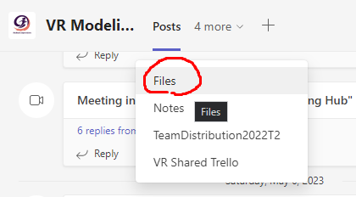

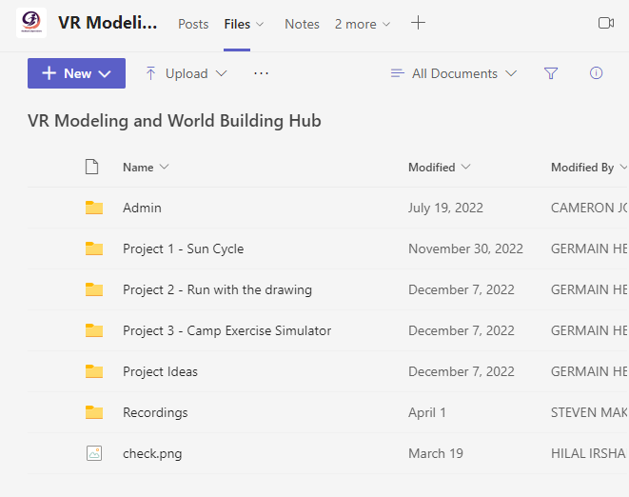

Opening the file “Project - Sun Cycle”

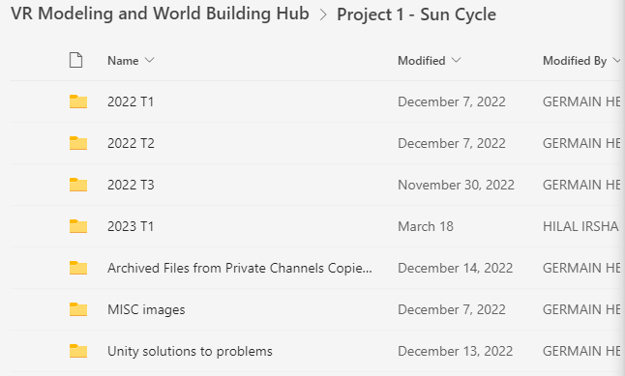

Files to the project on Teams (This are individual files and will not be shared with anyone If you make any changes to them):

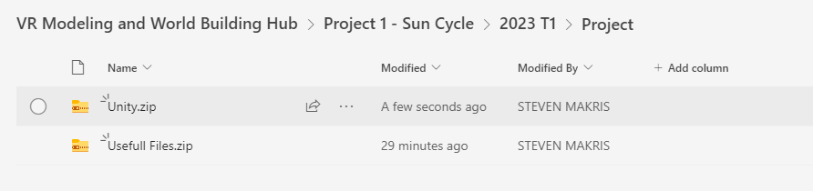

## **3.2. Trello**

We use Trello to organise the tasks that need to be completed, the status of said tasks and who is assigned to each of the tasks.

Trello: <https://trello.com/b/aXyBMyGf/project-sun-cycle>

Overview

This image demonstrates how we categorize our cards (tasks) into their respective statuses such as “To Do”, “Doing” and “Done” which contains tasks from the roadmap (past trimesters) that we could decide to work on. To move these cards to a different list you can just click and drag them.

To do: add a trello image of our overall board

New Tasks

1. When you want to create a new task, you can click the “Add a card” button under each list.

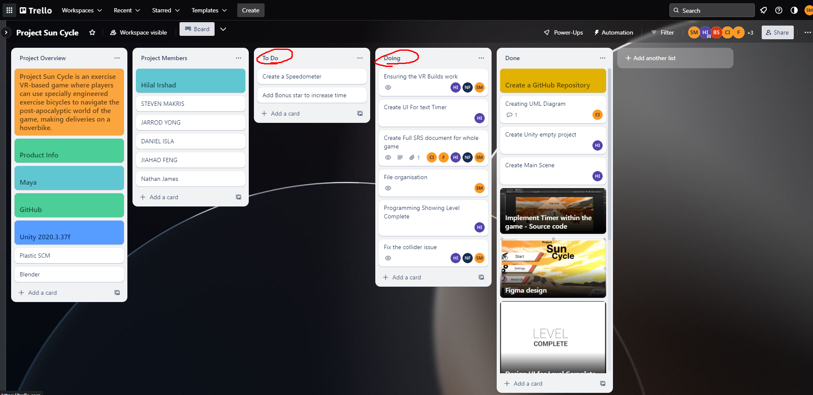

1. You can then add a task title to that card.

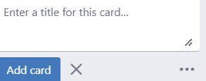

1. Once you have a new card you can select that card to go into the details and add a description to better define the workload of the task.

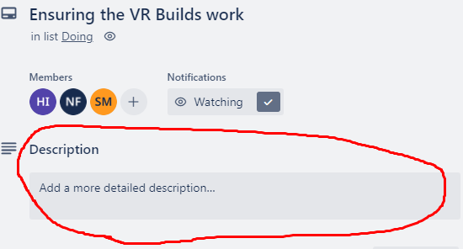

New Lists

1. If you want to add a new list to help categorize your cards, click “Add another list”.

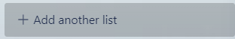

1. Once you have clicked that enter the name of list you want and then click “Add list”.

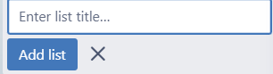

Assigning Members

When you have decided on a task you want to contribute to you can drag a user from the top right onto a card to assign that team member to the task.

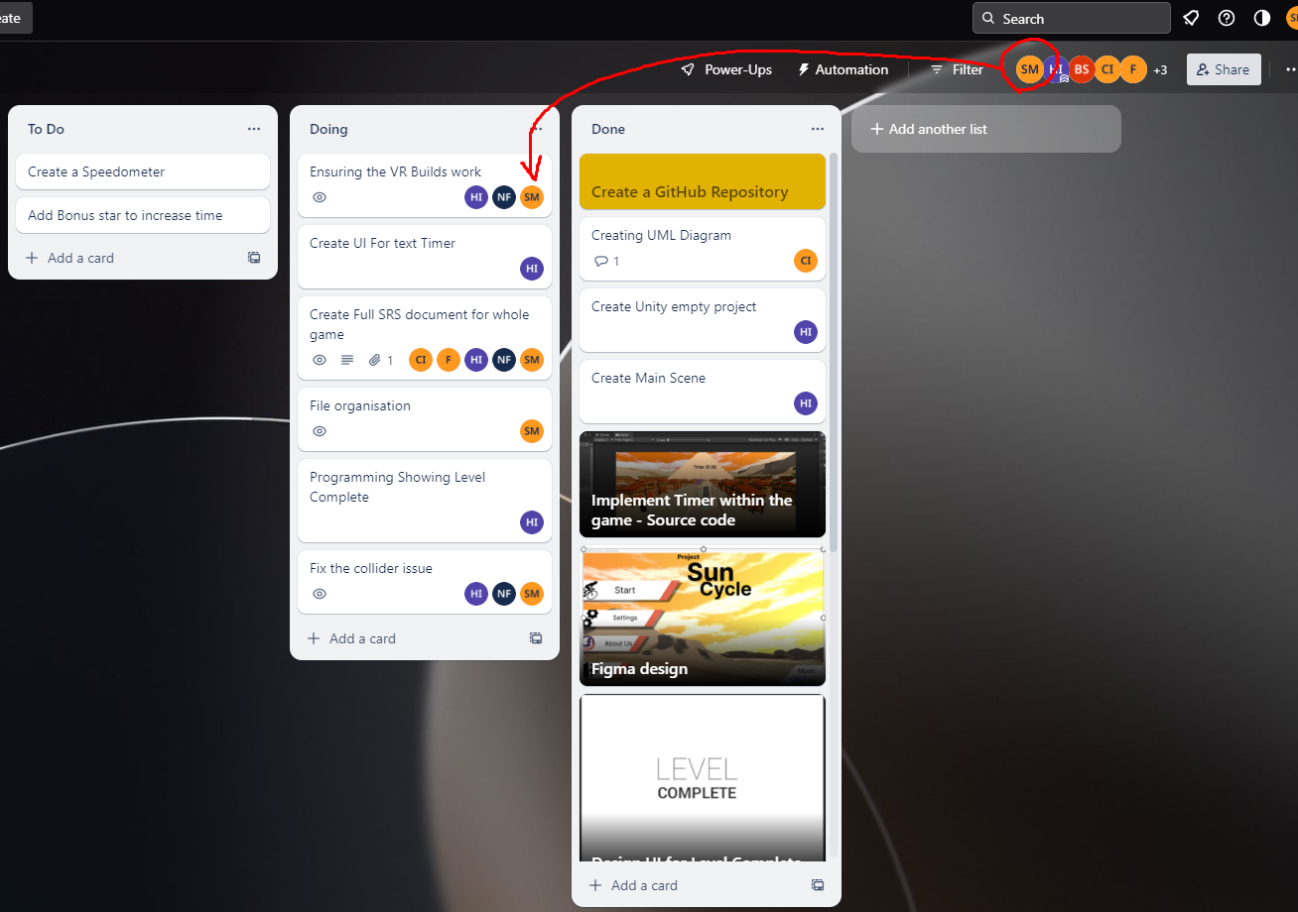

Trello activity history

1. To see the activity in Trello, click the three-dot icon in the top right.

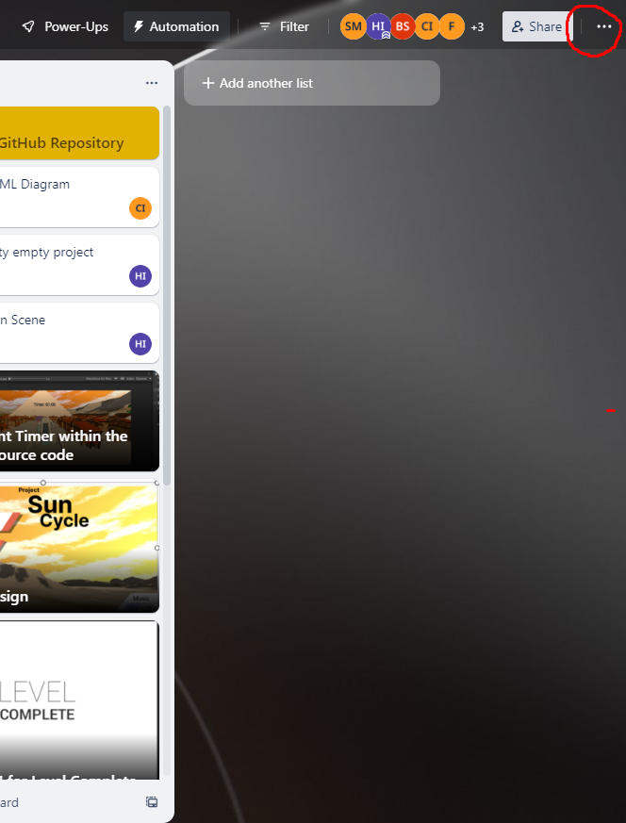

1. You can then see the history of your Trello board’s activity.

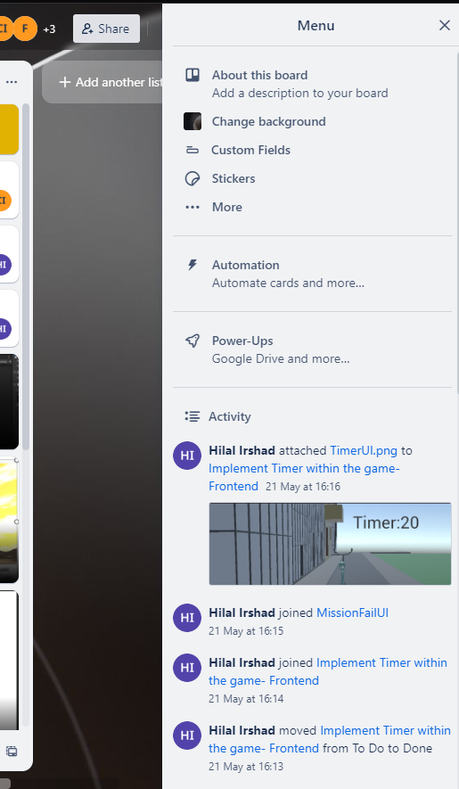

## **3.3. Unity (Editor Version: 2020.3.37f1)**

Unity is the game engine we use to develop our project. We are using Editor version

## **3.3.1 Installation and setup**

1. The First step is to create a Unity account. Go to the Unity website and “Create a Unity ID” (make an account).
2. The second step to using the Unity software is downloading it. Go to this link:<https://unity.com/download> and select and download the version that matches your circumstances (Operating System). Once downloaded execute the setup for the Unity Hub.
3. Launch Unity Hub and after you have logged in you will get something like this.

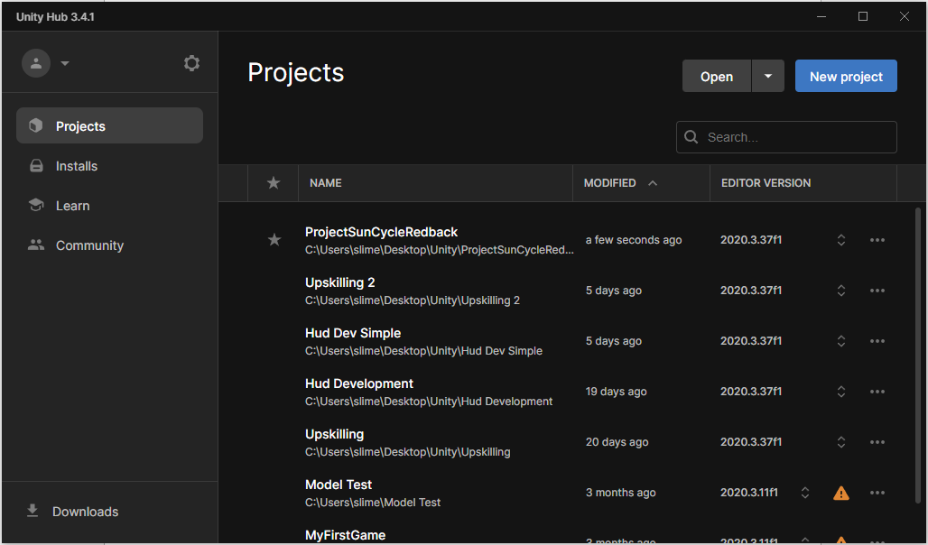

1. Now we will need to install the Editor Version that we are using for the Sun Cycle project. Go to the “Installs” tab on the left and then click the “Install Editor” button in the top right.

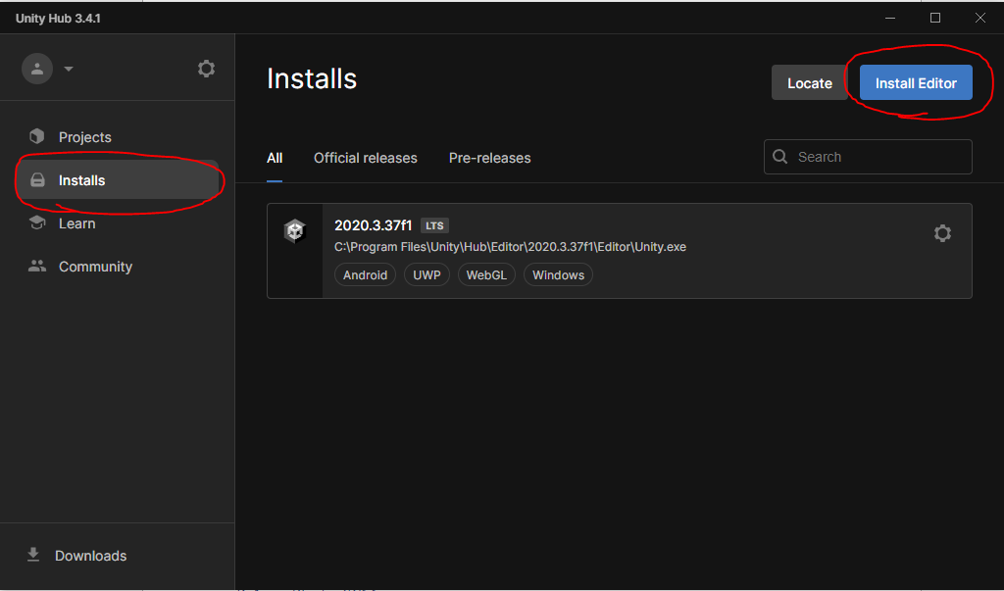

1. Then click on the "Archive” tab and click the download archive link (<https://unity.com/releases/editor/archive>).

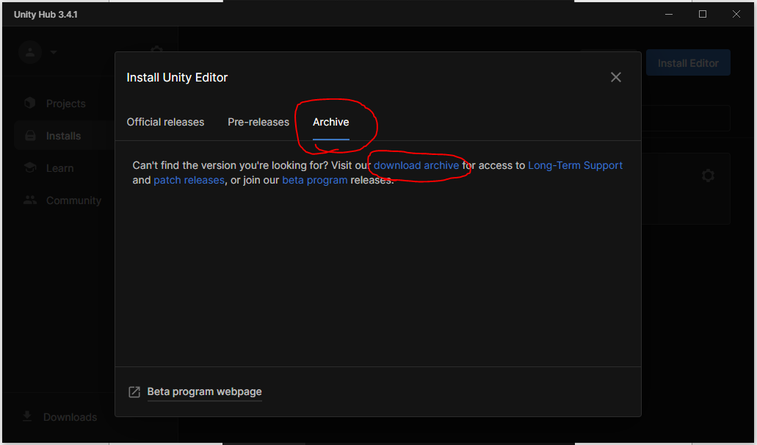

1. Then scroll down and select the “Unity 2020.X” tab. Then scroll down to the Unity Editor Version 2020.3.37 and click the “Unity Hub” button.

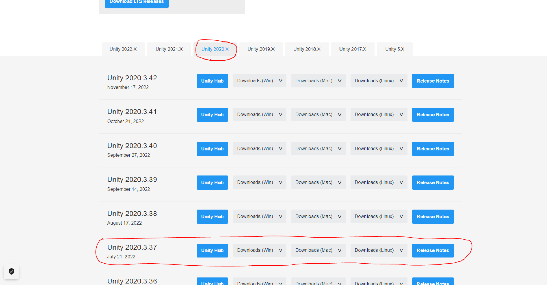

1. This will take you to the Unity Hub again where we will get to choose the Modules we want to add to the Editor. In this case we will want to add the Android Build Support for the VR headset.

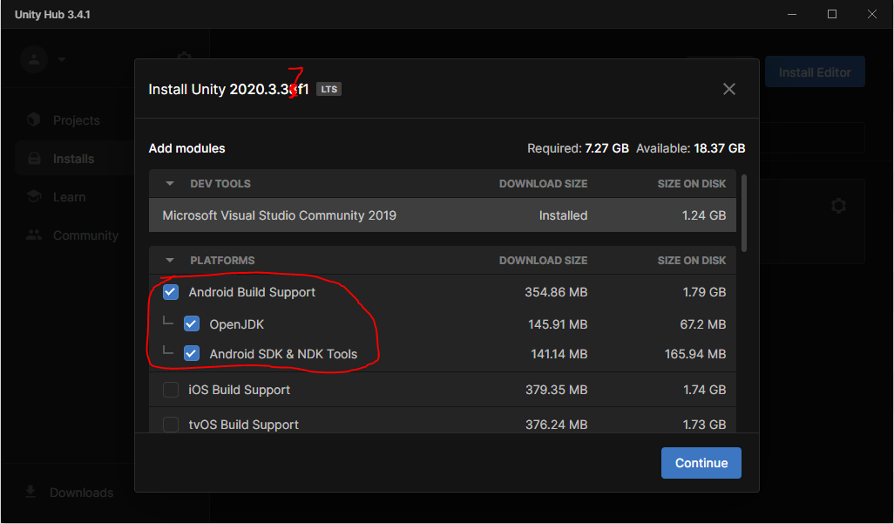

1. You can also choose to add other modules if you wish to test or build the project for other platforms. For example, I might select these modules as I use Windows OS:

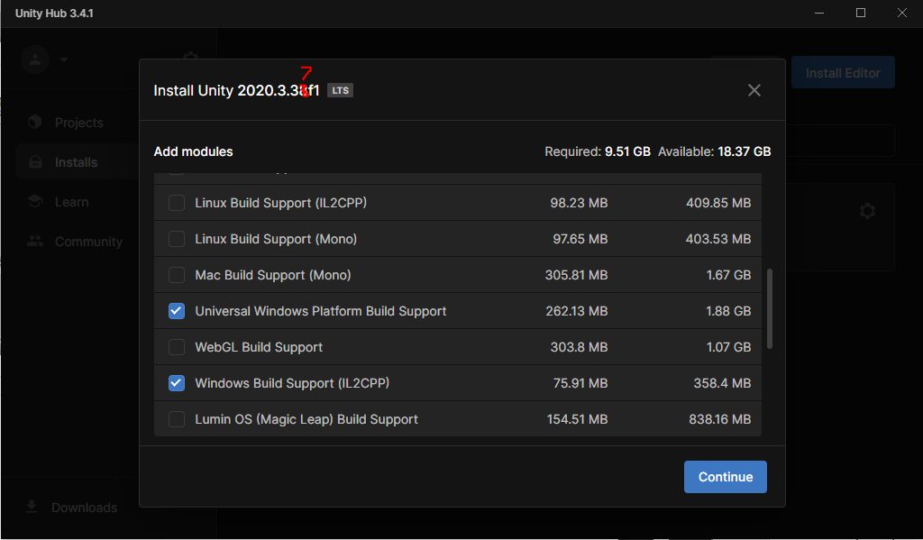

1. Then click "Continue” and accept the terms and conditions and click “Install”

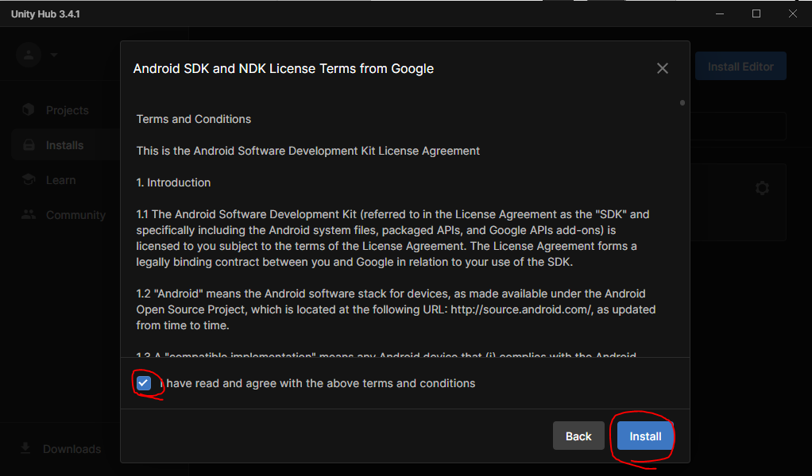

1. Once it is done installing should show up in the “Installs” tab.

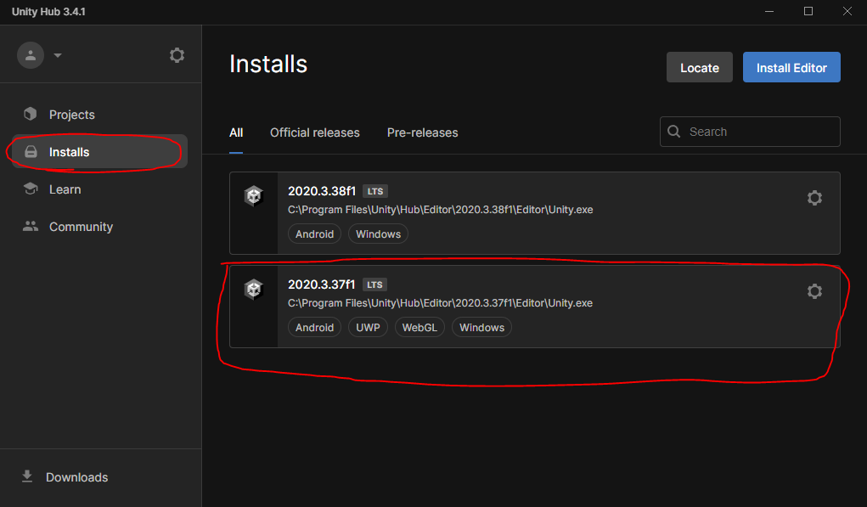

## **3.3.2. Basics of Unity**

Below explains the functionality of some of the most important windows/panels in Unity but there are many more you can use for specific things. It’s a good idea to Upskill in Unity before usage.

Hierarchy

This contains all of the game object that are currently within your scene, in this case “MainScene” contains “HumanoidNPC” which you can see in the middle.

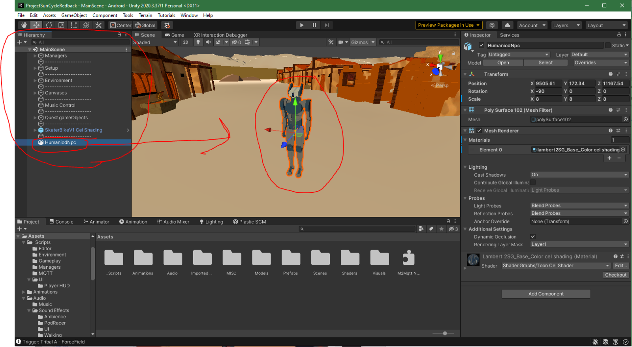

Scene

The scene is kind of like a level in a game, you add things to the scene that you want in that level. Through this screen you can add and manipulate the game objects in the level and design the world just the way you want it for the player to experience it.

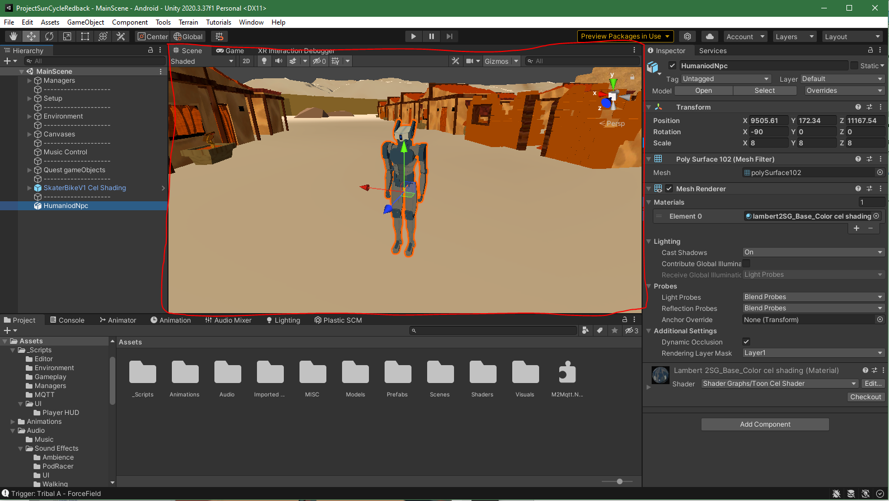

Inspector

Once you have clicked on something in either your Hierarchy or your Scene to select it the Inspector will pop up with the details of the selected object. It will show you all the different components of that game object, in this case the robot has a transform (position, rotation and scale in world space) and mesh renderer (renders the 3D mesh and material). Though this panel you can add or manipulate components.

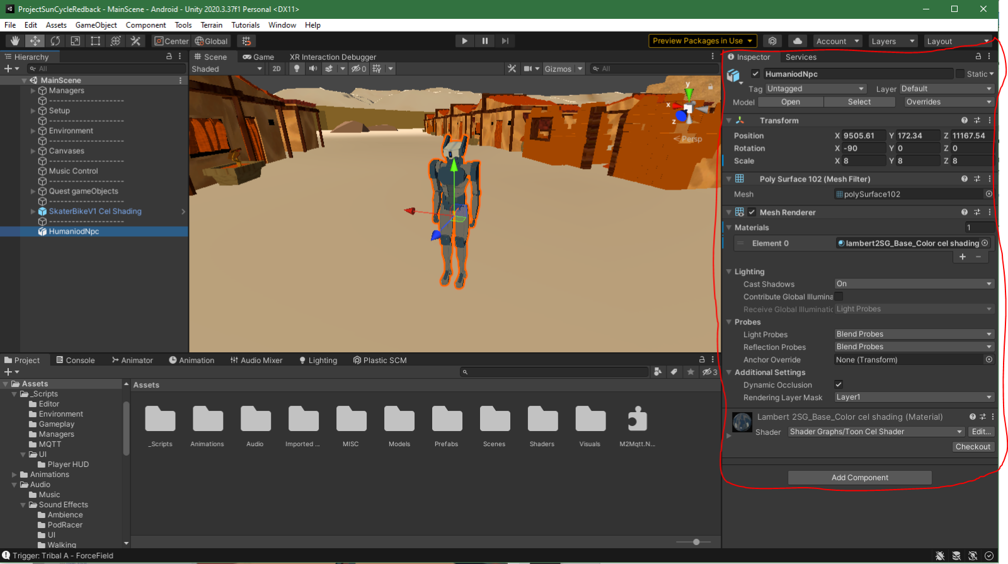

Project Directory

The project directory stores all of the assets that you are using in your project, things such as Audio, 3D models, textures, scripts, shaders, etc. You can use these assets to create game objects in any way you want. You should try to keep these files organized with simple understandable names.

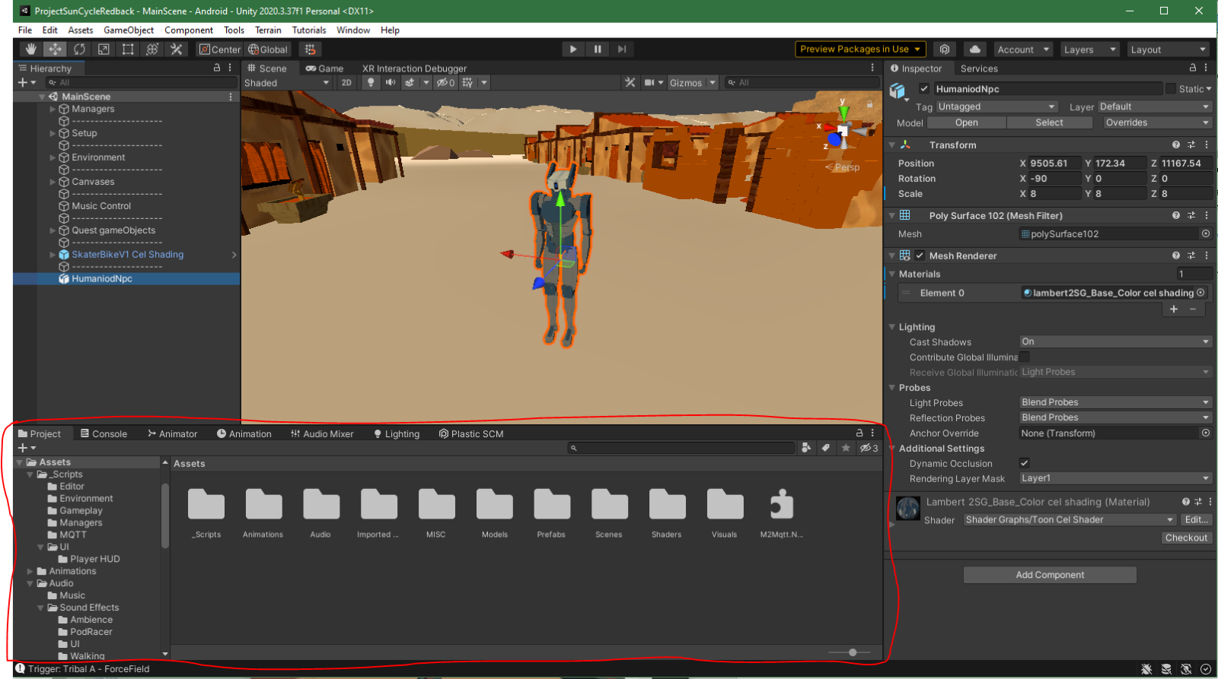

Console

You can use the console panel while testing your game to debug your game and ensure it is free of errors. The three clickable boxes in the top right of the panel allow you to turn on debug messages, warning messages and error messages. You use these messages to diagnose and fix problems with the project.

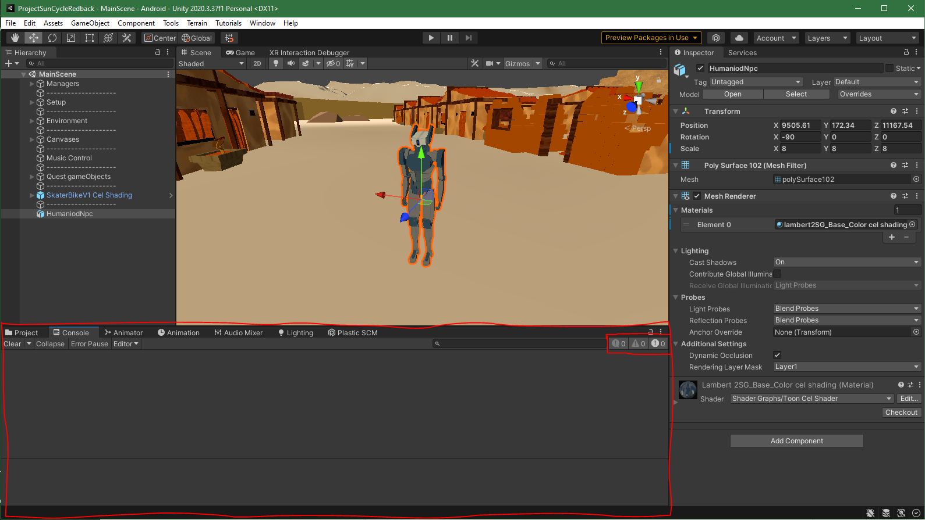

## **3.3.3 Build settings**

Building the project is basically the process of creating the stand-alone version of the game that can be run on a specific platform as an executable. Because we want this game to run on a VR headset, we need change the platform to Android.

1. Go to “File” -> “Project Settings…”

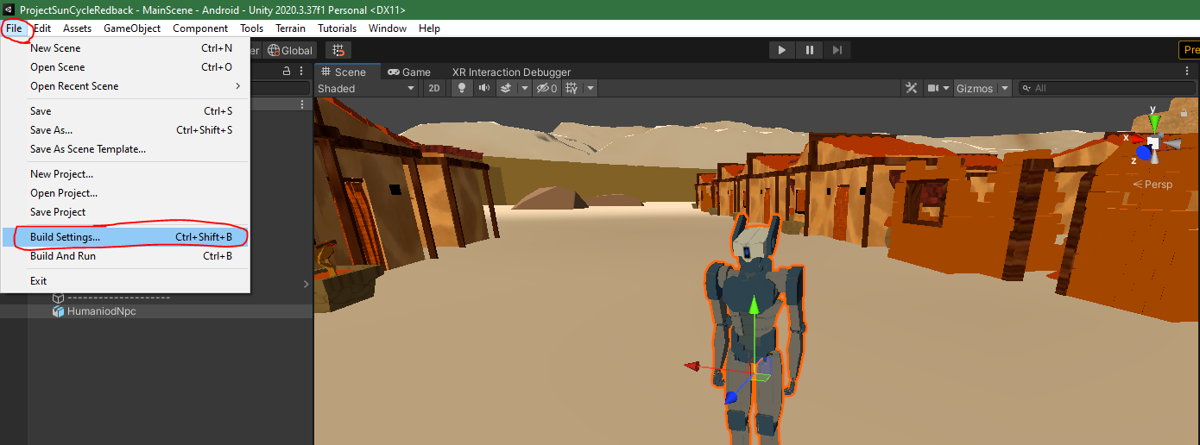

1. Once you are in the project setting click on the “Android” tab and click “Switch Platform”

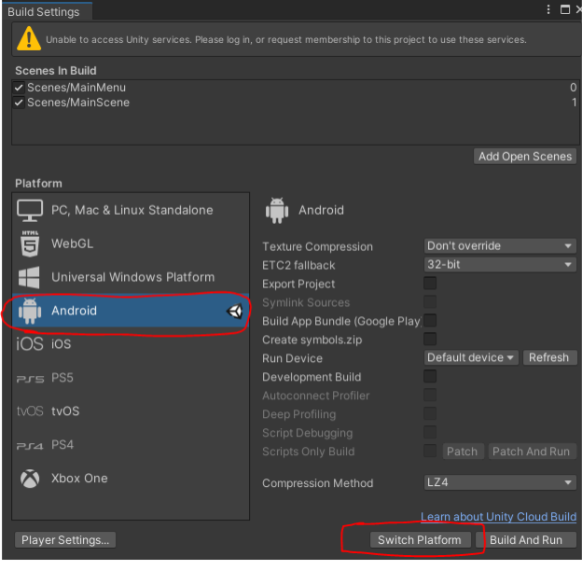

1. After this process is finished you will be able to make a build of the project by clicking the “Build” button, this will be stored as an executable file wherever you choose the location to be.

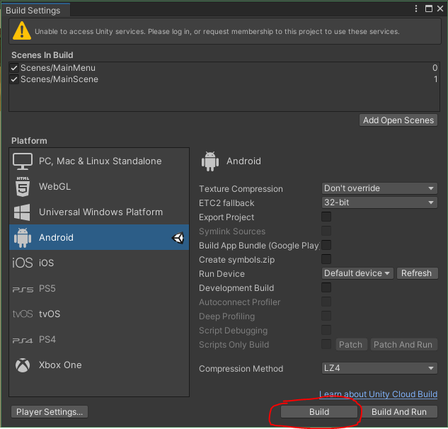

## **3.3.4. Using VR Headset**

**Note**: this section contains biased information based around the Oculus/Meta Quest 2 headset.

1. Have Oculus application open.
2. Have Unity project open.
3. Install & Setup oculus app on your phone.
4. Watch this short video to turn on developer mode on your headset:<https://www.youtube.com/watch?v=75dHXROt4mE&ab_channel=HowToGeek>
5. Connect VR headset to computer using cable (or use air link, not recommended).
6. Accept popups on the headset.
7. Launch Quest link on headset.
8. In Unity go to “File” -> “Build Settings...”



1. Then go to the “Run Device” section and hit “Refresh”, once that is done click the “Default device” dropdown and select “Oculus Quest 2”.

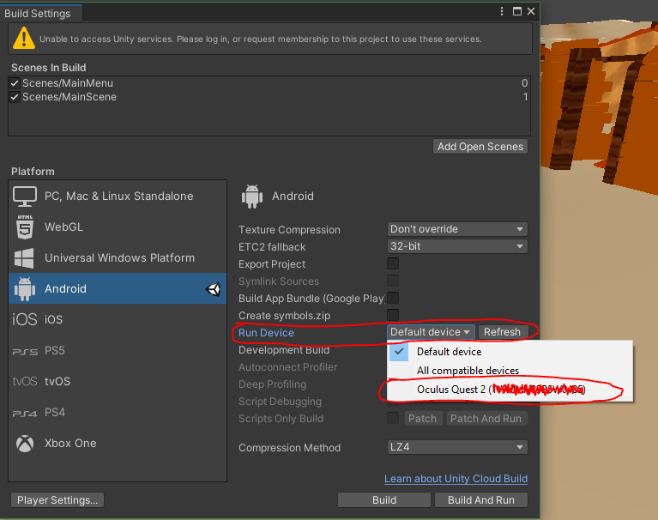

1. Click play button in Unity to test the game in the editor on your headset.
2. If you want to build a stand-alone version of the game on your headset, just click the “Build” button in the Project Settings and after it is done building you can unplug your headset.
3. To find the stand alone build go to your apps on your headset and click the dropdown menu in the top right and then sort by “Unknown Sources”.

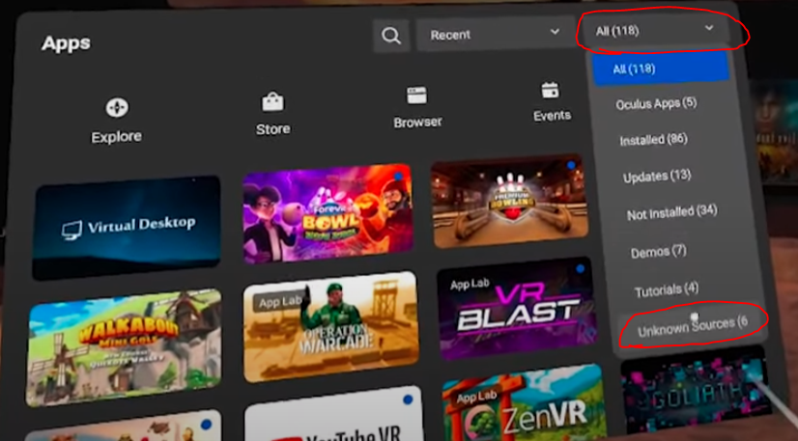

## **3.4. GitHub**

A central centre for version control and developer collaboration, GitHub is a web-based platform. It offers Git, a distributed version control system that enables multiple users to work on the same project at once without overwriting one another's modifications.

Github Link: <https://github.com/redbackoperations/VR-T12023>

## **3.4.1. Setup Github**

A contributor access is required in order to operate on your GitHub repository and guarantee that all files are preserved. Without contributor status, certain files may be unavailable or missing during the collaboration process.

Ask the company leader to gain contributor access.

1. Now that you have contributor access. Open Github and download “Download only me & READ ME FIRST” & “Download only me & READ ME FIRST”

I will include the contents of these files here.

1. “Download only me & READ ME FIRST” file:

# VR-T12023

To work on this project please read 'GitHub how to upload 100mb+.docx' first,

because Github won't allow you to upload more than 100mb.

On the files Unity. You will find our game.

Do not Use the Backup one as it is in a safe state of the current game.

Backup should be used only when all the changes made are safe to be transferred

without breaking the current state of the game.

# Instructions

You cannot clone it until you have read 'GitHub how to upload 100mb+.docx' and follow the steps

1. “GitHub how to upload 100mb+” file:

**This Document is to show you how to upload more than 100mb on GitHub and work on the project.**

1. **Download Git. Don’t change any option during the installation except the default editor for Git if you want.** [**https://git-scm.com/downloads**](https://git-scm.com/downloads)
2. **Download Git LFS** [**https://git-lfs.com/**](https://git-lfs.com/)
3. **Download GitHub Desktop** [**https://desktop.github.com/**](https://desktop.github.com/)
4. **Clone the repository on GitHub desktop.  
   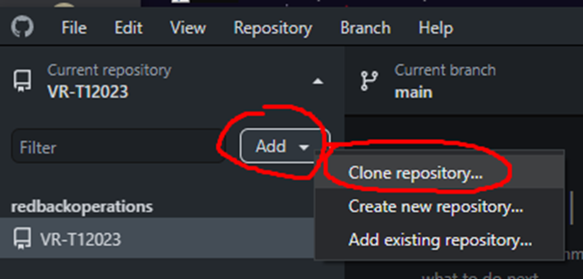**

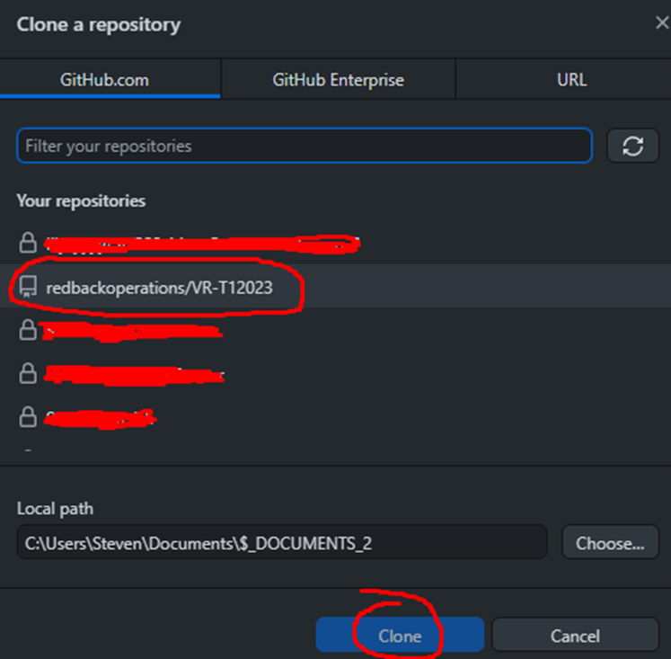

**It will ask you if you want to initialize GIT LFS. You need to Initialize it and accept it if you want all the files to be there and working.**

**Now you can Open the Explorer:**

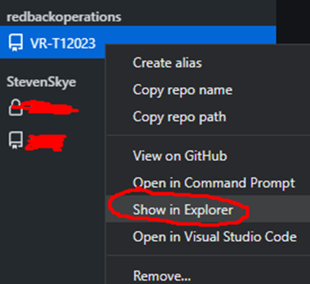

1. **Now you should be able to work on the repository and make changes. You don’t have to read the following steps except if you want to know how Git LFS work.**
2. **Right click on the Explorer file (where the GitHub repo is)  
   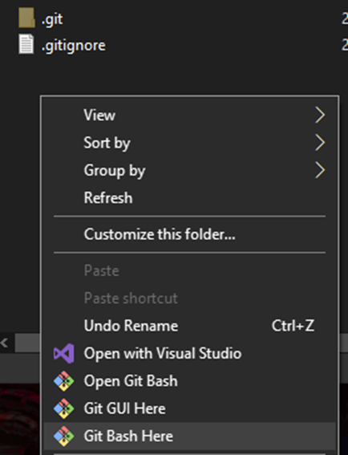**
3. **Click on Git Bash Here  
   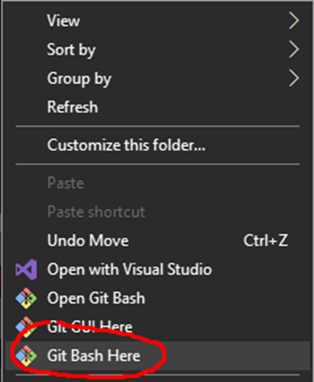**
4. **Mingw64 will open and write the command: git lfs install**

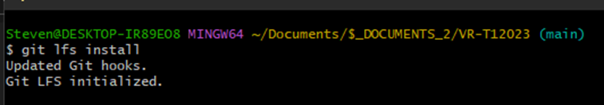

**This will initialize Git LFS**

1. **Open the Unity Project and make sure the project is “Force Text” (Usually this is the default option)**

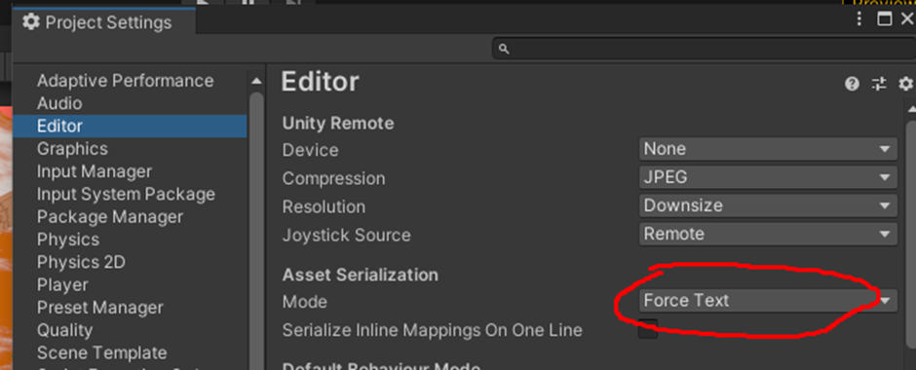

1. **Now we want Git LFS to track files that can be over 100mb. For now, we use .psd (If .gitattributes already exist. You do not have to do this part Go to step 13.)  
   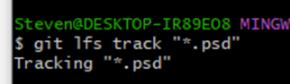**
2. **A new file will be created that tracks the specified files.  
   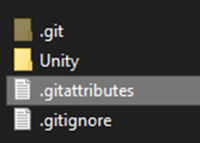**
3. **Now when you try to commit a new change to the project and a file is over 100mb. Check its file extension.  
   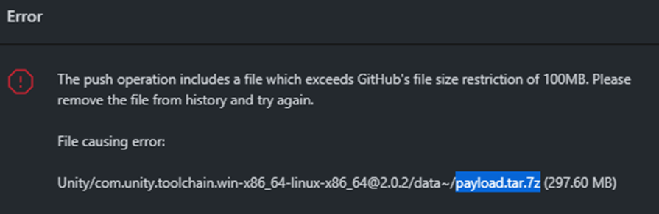**
4. **Open .gitattribrutes and write this code**

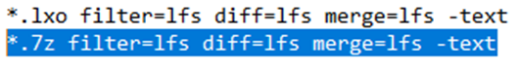

1. **Now Commit .gitattributes first and then commit the change that was more than 100mb. If you try to commit the change that include 100mb. It will not accept it. You need to commit the change of .gitattributes to accept your file that is more than 100mb**
2. **This code will show all the files that have been track by Git LFS  
   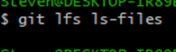  
   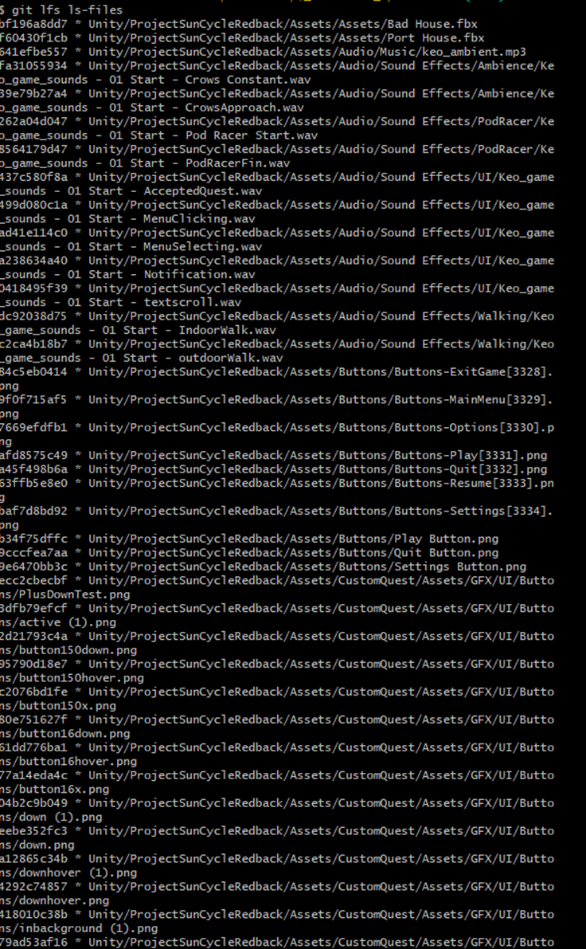**

1. **Now you should be able to upload more than 100mb**

## **3.4.2. Using GitHub with Unity**

Todo: How to use gihub with unity and how i works

After completing 3.4.1. We can now use Github Desktop to share files.

Find the local path in your computer and open it:

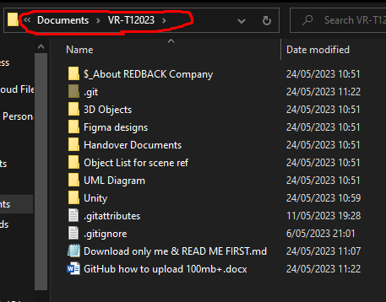

Here, any changes you make. Will also happen on **“GitHub Desktop”**

For example if you create any file (I will create a text file called “Test”). The change will appear on “Github Desktop”

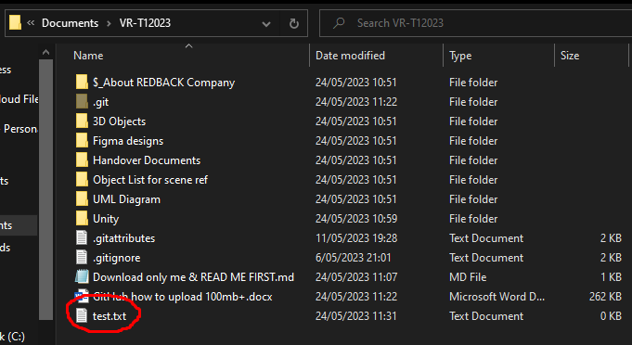

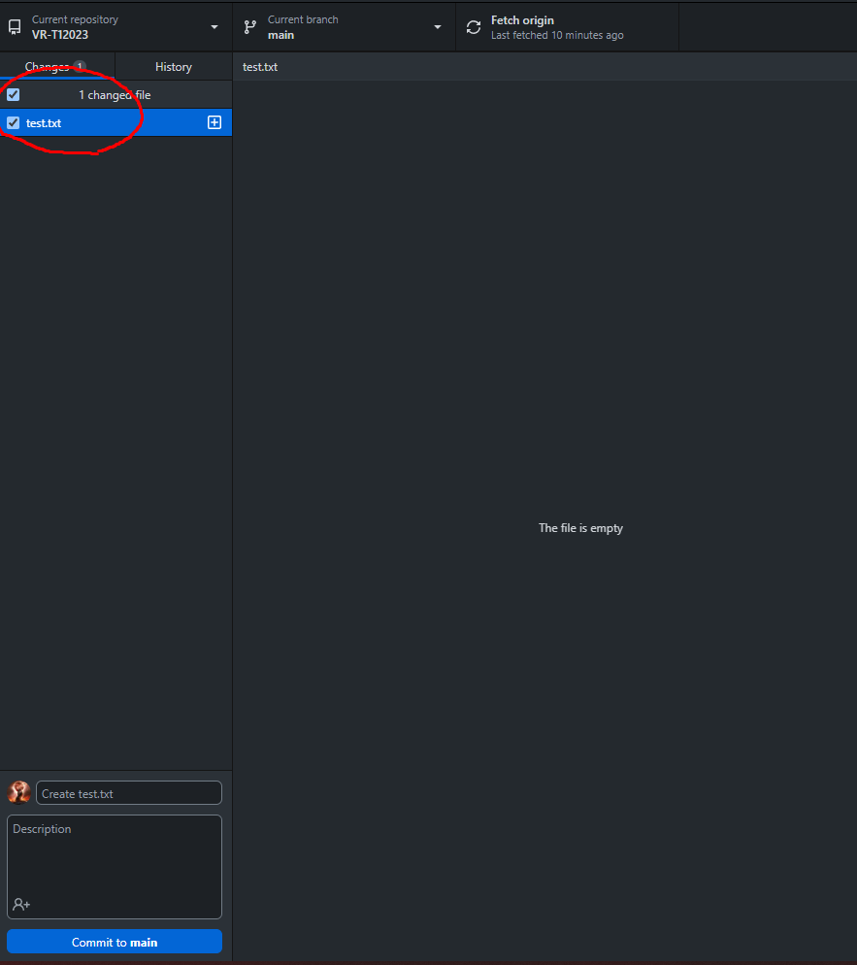

Now you can write anything on that file and it will automatically go to ‘GitHub Desktop’ if you save it.

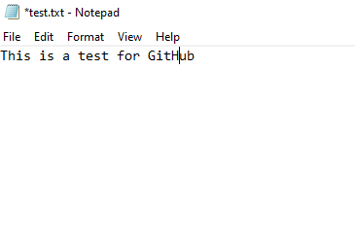

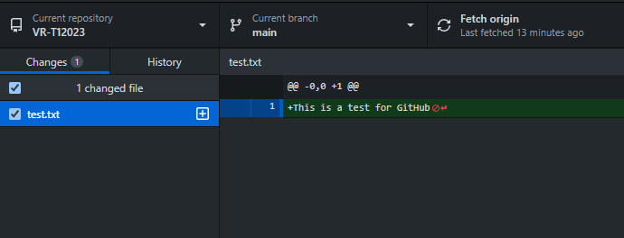

To actually share your files with the team you have to commit and push the change:

Commit:

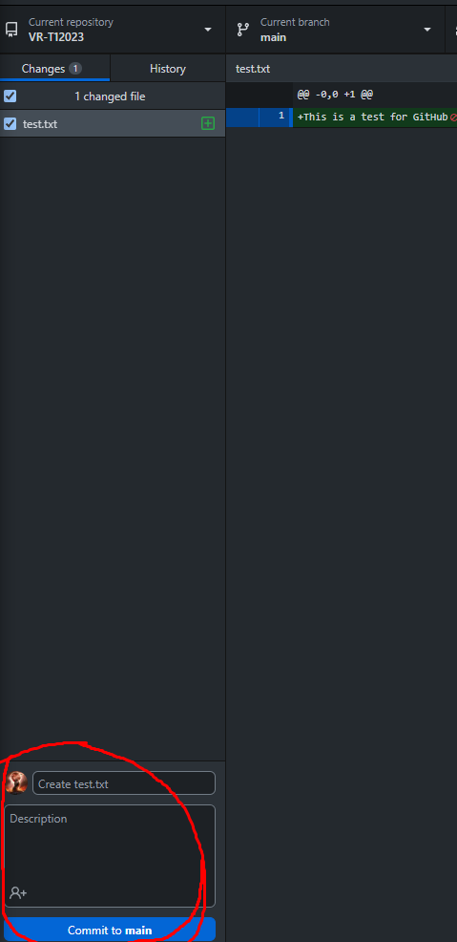

Usually you have to write a small summary above the Description for the “Commit to main” activate.

Now that you have pressed the “Commit to main” button. You have to press “Push origin”

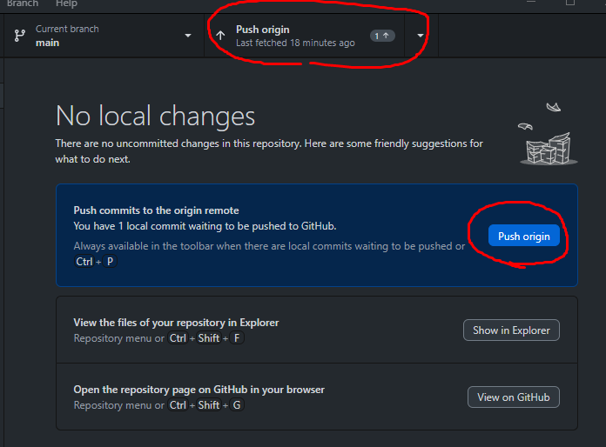

To receive a change from other members. You have to press the “Fetch origin” button and download all the changes.

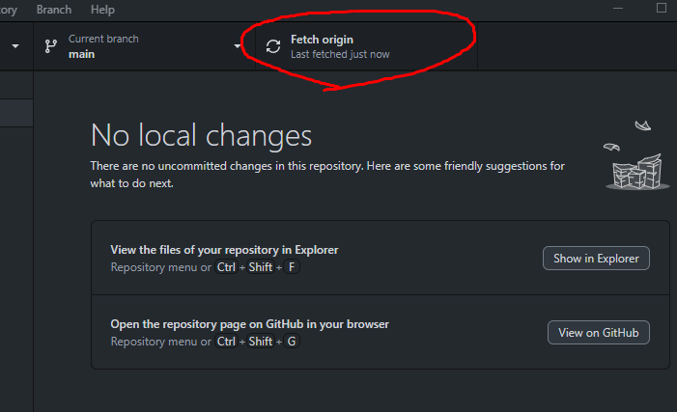

**Important Note:** Always “Push origin” and “Fetch origin” all the time for everyone to be up to date with the files. Otherwise “Conflicts” within files may appear that can set back team’s project

## **3.5. Blender / Maya / 3D Max**

**Note**: this section contains biased information based around the 3D Max software. It’s your choice however for which 3D software you decide to use.

This section will contain basic information on how to use a 3D software application to create and export an asset.

## **3.5.1 Installation and setup 3DMAX**

1. Create an Autodesk account if you do not have any, go to 3DMAX website and create a new account.
2. You can get a Free trial if you are a university student and did not use before, then choose the operating version and download Autodesk.

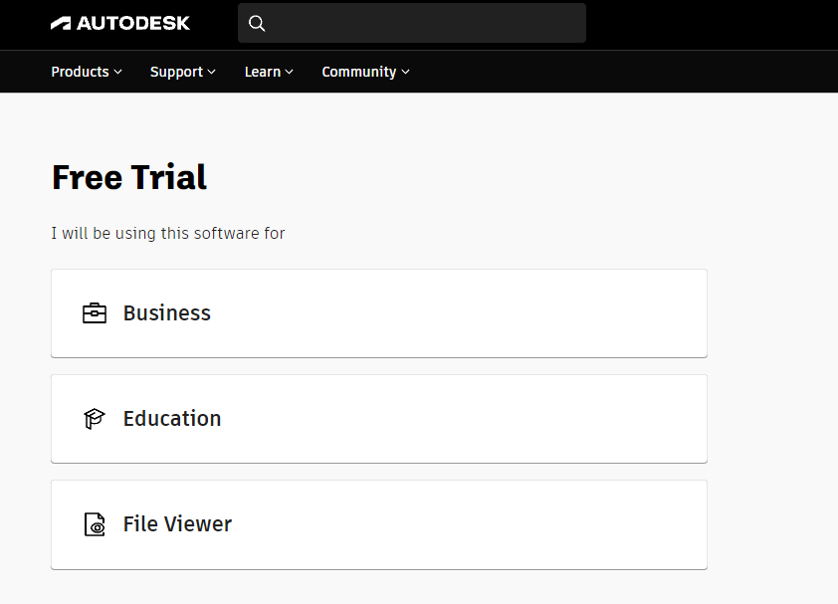

1. Open the Autodesk application, download the 3DMAX tool.

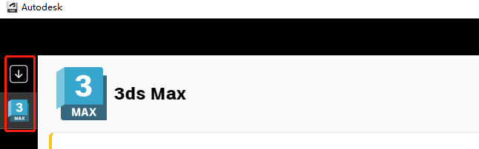

1. Open the 3D MAX software and use the tools provided to create your model.

1. You can then modify the model through the edit bar on the right while observing the model, but please note that model modification will affect the application of textures

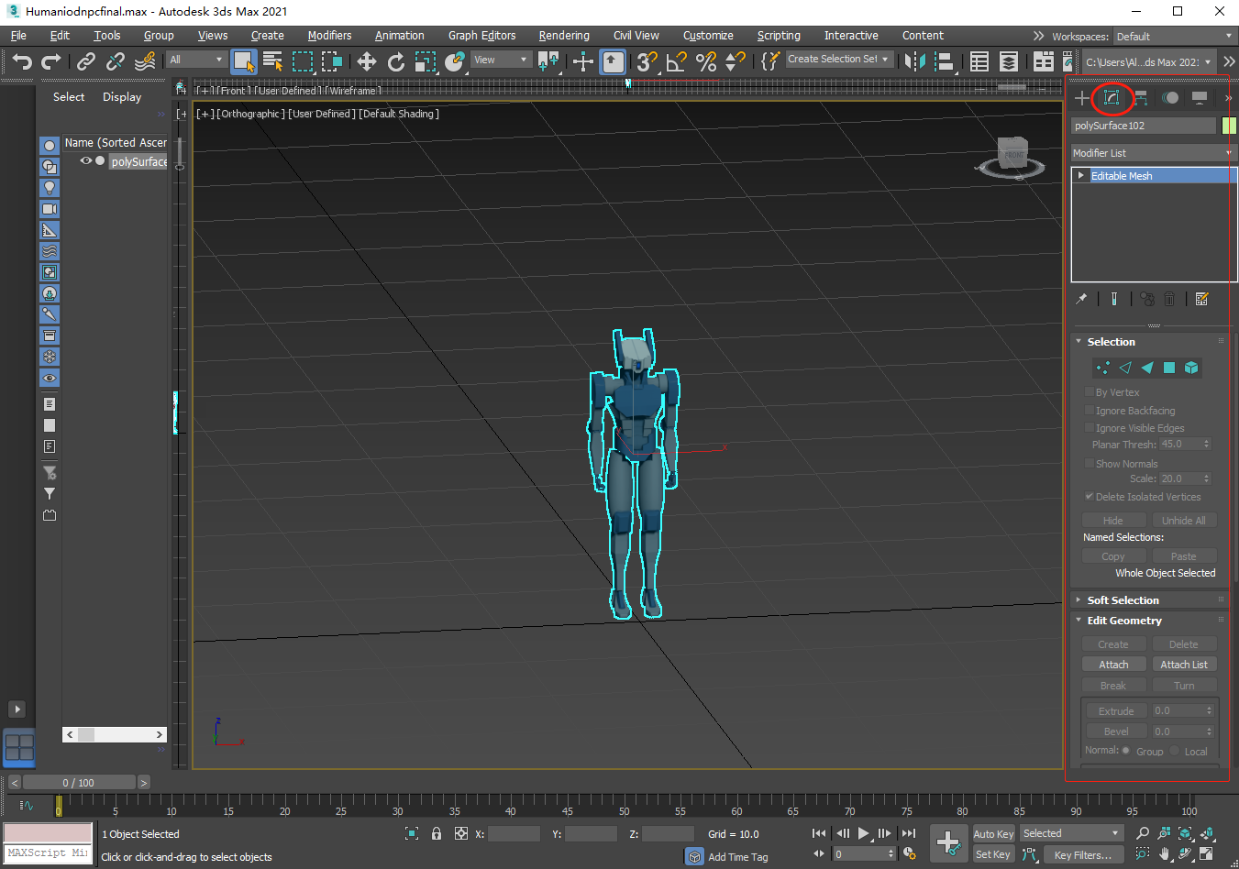

1. Click the shortcut key “M” to open the material editor, view the texture and apply the model by dragging the shader.

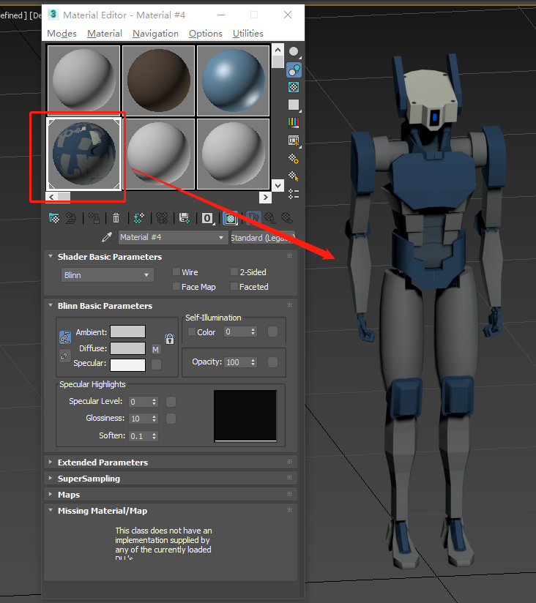

1. Export the model and convert it to any format you want. 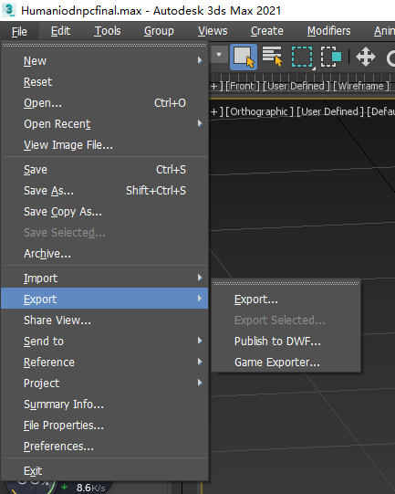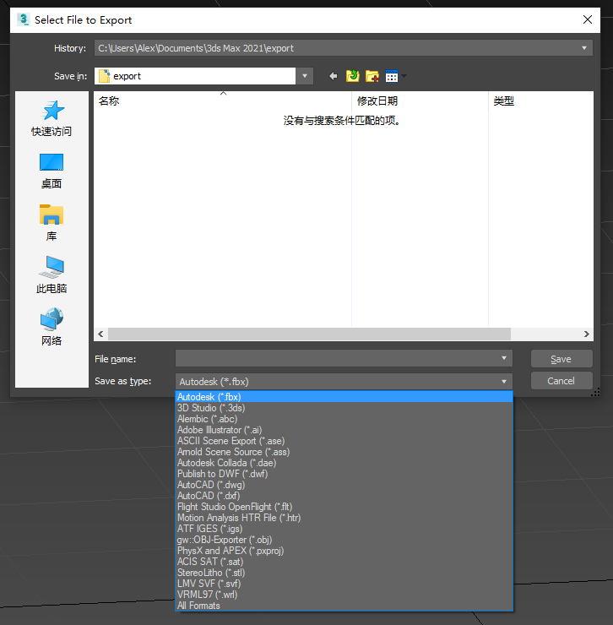
2. Store the exported file somewhere easily accessible by the Unity Team (Microsoft Teams Files) who can then import your model into the project.

# **4. Deliverables**

| Trimester Deliverables | Status | where |
| --- | --- | --- |
| Added GitHub for better accessibility | Done | GitHub: <https://github.com/redbackoperations/VR-T12023> |
| 2 new 3D Models for Bicycle option | Done | Github |
| 3D models (objects) for the Desert Map | Done | Github |
| Better Organization of Github Files | Done | Github |
| New map called “City” | Done | Github |
| 3D Model of the City | Done | Github |
| User is able to choose a bicycle | Done | Github |
| User is able to choose a Map | Done | Github |
| End trigger | Done | Github |
| Timer | Done | Github |
| Collision | Half-done | Github |
| Movement | Half-done | Github |
| Add Bonus star to increase timer | Not done | N/A |
| Create a Speedometer | Not done | N/A |
| UML settings/controls | Done | Github |

# 5. Open Issues

* Issue that will come again and again: Merging scene’s can bring conflicts. The reason is that two users use the same “asset/model” to do different things. That brings a pandemonium to the scene that can’t be resolved. To resolve it, one scene must be accepted as the current one. The second scene that has the changes needs to be put back one by one to the first scene. Put back the scripts/models/assets etc. at the hierarchy.
* Desert map has collision issues
* City map the collisions aren’t fully implemented
* Setting is not functional
* Quit is not functional

# **6. Lessons Learned**

Our team started working on a Unity game development project during this trimester, and as a result, they learned a lot. Following are some of the most important takeaways from the project, along with suggestions for incoming teams:

**Managing the scope:**

Throughout the course of the project, we came to understand the value of efficient scope management. When we first started, our team had big goals and wanted to include a lot of features and functionality. But as time went on, it became clear that our scope was too broad, which limited our options and reduced the quality of our work.

Future teams should give careful consideration to realistic scope planning and early project goal setting. It's crucial to establish the fundamental gameplay and features in accordance with the time and resources available. As a result, the development process can be more narrowly focused, and the intended quality requirements are met by the finished product.

**Optimization and Performance:**

As our project was ongoing and expanded in complexity, we ran into performance problems that impacted the overall smoothness and enjoyment of the game. This was mostly caused by ineffective resource management, inefficient code, and a lack of early performance consideration.

Future teams should start the project by giving optimization and performance considerations a top priority. This entails putting in place effective algorithms, controlling memory use, and profiling the game to find and fix obstacles. Early speed optimization can help teams avoid laborious refactoring later on and guarantee a smooth gaming experience.

**Sharing of knowledge and documentation:**

We came to understand the value of thorough documentation and team members exchanging information. Confusion and inefficiencies resulted from our initial failure to properly explain critical design choices, code structure, and project guidelines.

The culture of documenting and information sharing should be established by future teams. In order to do this, it is necessary to keep technical requirements, architectural blueprints, coding standards, and user manuals and guides current. Future teams will gain from the quicker onboarding of new members and easier collaboration during various project phases.

**Issue with User Interface (UI) Design:**

Initially, we undervalued the significance of usability testing and UI design that is intuitive. As a result, there was user confusion, poor navigation, and a poor user experience. Future teams must allocate enough time for usability testing and UI design. It is essential to design a user interface that is both aesthetically pleasing and efficient at guiding players through the game. Usability testing with representative users can assist identify navigation issues, highlighting problems with users, and enhancing overall UI design.

**Regular Knowledge and skill development:**

We as a team came to the conclusion that creating games with Unity is a lifelong learning process. We faced difficulties that compelled us to go beyond our original capabilities in terms of knowledge and skills.

Future teams should actively participate in ongoing skill development and learning throughout the project. This can entail studying online guides, taking part in Unity forums and communities, watching tutorials or doing online courses that can help them, and encouraging team members to share their knowledge. Teams may overcome obstacles and produce high-quality games by keeping up with new Unity features, industry trends, and best practices.

**Issue of loading assets into Scene:**

Managing game elements, such as music, sound effects, and art assets, proved challenging. Keeping track of asset versions, ensuring consistency in style and quality, and effectively integrating them into the game all become difficult tasks.

Future teams ought to put in place a formal asset management framework. This entails classifying assets into logical folders or categories, adhering to consistent naming practises, and managing assets using version control systems. Teams could also think about utilising the asset management solutions found in the Unity Asset Store to speed up the procedure and guarantee effective teamwork.

# **7. Product Development Life Cycle**

## **New Tasks**

Each week we would meet as a team to discuss either current tasks or possible new ideas, anyone who isn’t there can watch the recordings. Within the meetings we would go over our trello board that has all our tasks listed, each week we talk about new features we could add and take a vote on if they are good ideas to add or not.

Each person who comes up with the idea adds it to trello and adds the names of the people to work on it with them.

## **Definition of Done**

Each task is designated to a team member or a number of members, each member can check the trello board for tasks that need to be done. Once a task is finished we show it to the rest of the team in either our weekly meetings or one on one chat, once we agree it's done to an acceptable level we can change the task in trello into the done category.

A completed task needs to work as intended, and that the feature is tested by others.

## **Task Review**

Once a task has been said to be finished, the member/members working on it will post a message announcing the completion of the task. Typically someone would set a meeting with that person and get them to show that the new feature is working as intended before we push it in the repository.

# **Testing**

When we talk about a new feature we have a level of understanding of what it is meant to do and look like. Each developer does their own testing of the feature to make sure its up to par, after the developer tests it we pass it to the team to have them test and see if anything needs fixing or needs to change.

## **Branching Strategy**

As a team we use the repository to work more seamlessly as a team, keeping all our files for the project within the repository for ease of access and to keep organised.

Commits have to be looked over to make sure you're not deleting something very important. Besides that, we don't have any set rules for committing or pushing.

Each person has to name their changes for exactly what they have done, we try not to do the edit in multiple commits, we want changes to be in one commit to keep it cleaner.

After working with the repository I would suggest that the new team have the main branch for project work, but create sub branches for the extras of the project that might not need to go inside the actual unity file.

# **8. Product Architecture**

## **UML Diagram**

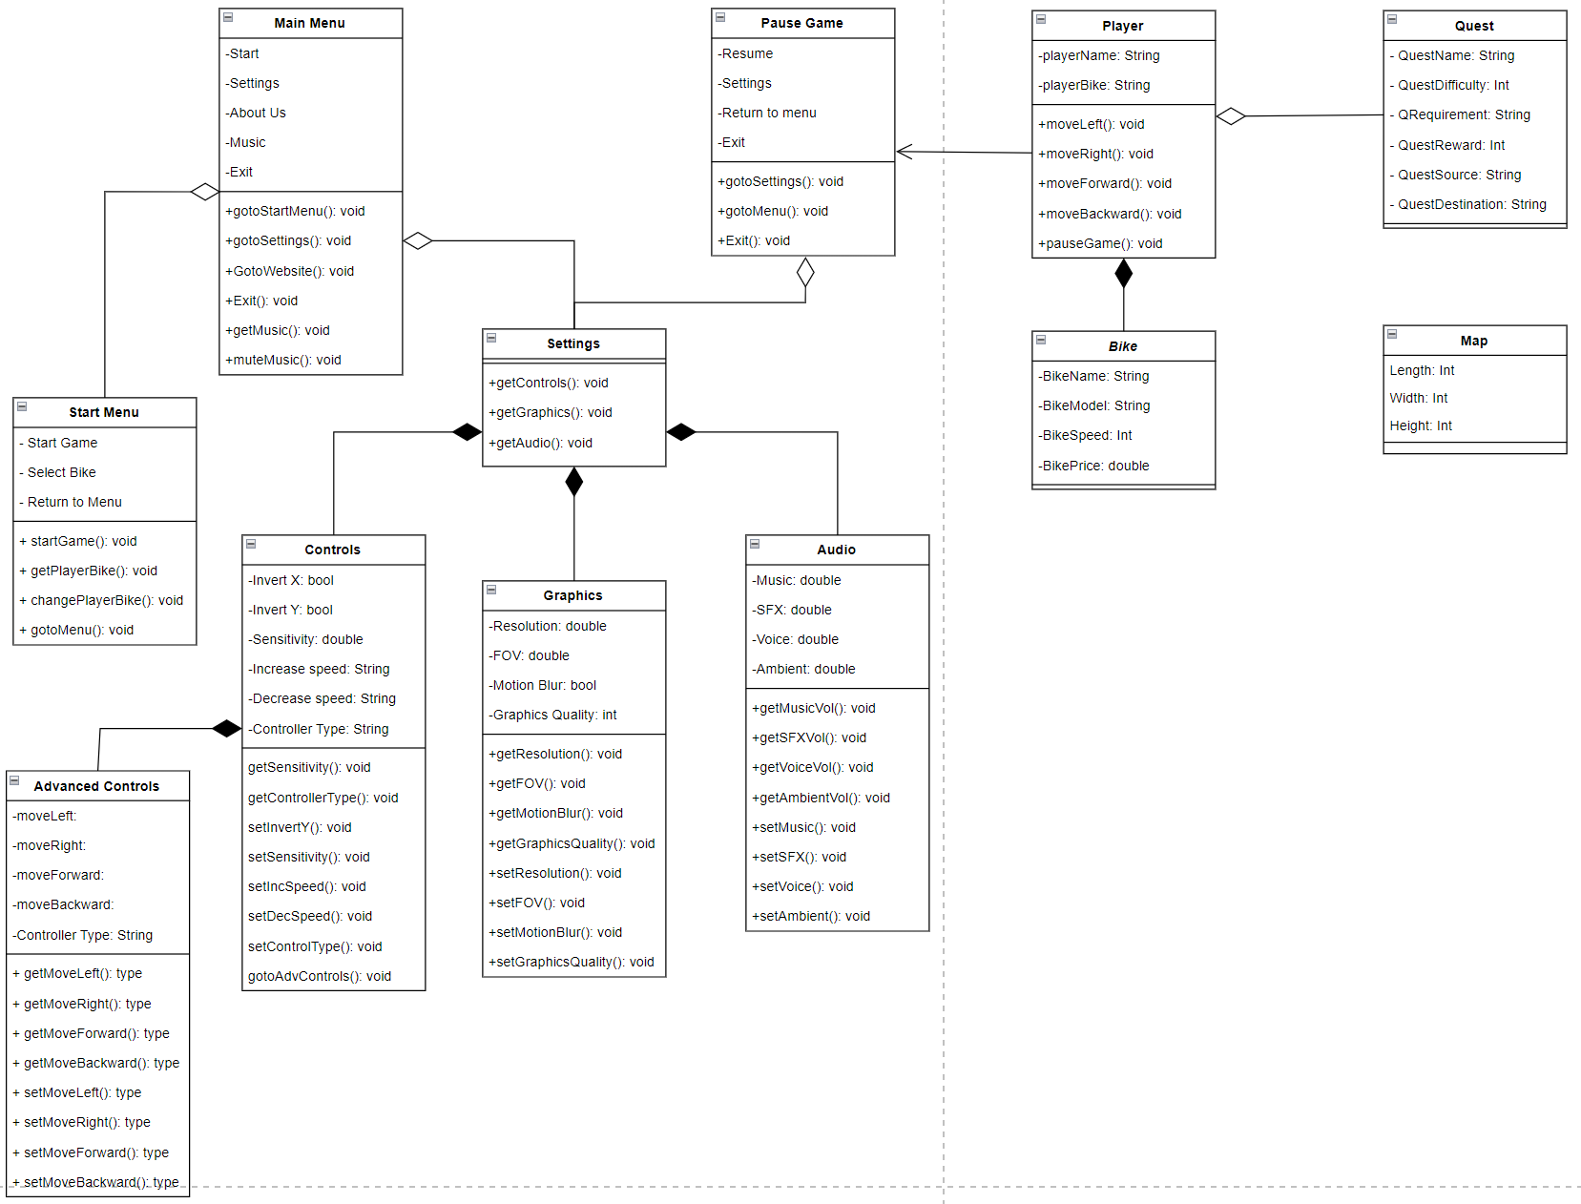

## **Tech Stack**

**Unity Editor 2020.3.37f1:**

A powerful game engine tool that allows users to build and develop gaming applications, which can be useful when creating games within a 2D or a 3D environment. This version is used due to its stability, and to its relatively low minimum requirements.

**Draw.io:**

A free and open source graphic designer used to create diagrams, flowcharts and UML diagrams.

This program was chosen due to its ease of use, its accessibility and availability.

**Figma design:**  
A collaborative program for designing interfaces for our project.

This program is used as it provides an easy way of creating visualisations and is collaborative, allowing multiple users to contribute.

**Github:**

An application that provides version control for projects in development, allowing users to continuously update a project.  
This is used as it is best for software development for both in person and online. It is also collaborative as multiple people can update files within a project.

**Blender:**

A strong open-source 3D creation tool is Blender. It is frequently used for many different things, such as video editing, simulation, rendering, and 3D modelling. Blender is a flexible tool for animators, designers, and artists since it supports a large variety of features and functionalities.

**Maya:**

The entertainment business makes extensive use of Maya, a potent 3D computer graphics programme, to produce stunning 3D models, animations, simulations, and visual effects. It is created and maintained by Autodesk, a top software provider for computer-aided design and the production of 3D content.

# 9. Appendices

## **9.1 Showcase Video**

Showcase Video:

[showcase.mp4](https://deakin365.sharepoint.com/:v:/r/sites/RedbackOperations9/Shared%20Documents/VR%20Modeling%20and%20World%20Building%20Hub/Project%201%20-%20Sun%20Cycle/2023%20T1/showcase%20video/showcase.mp4?csf=1&web=1&e=xFqPCw)

## **9.2 Documentation Deliverables**

Organization of GitHub files

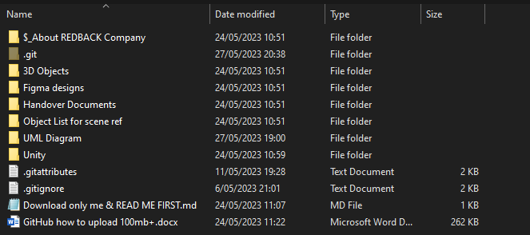

## **9.3 unity Deliverables**

**End trigger**

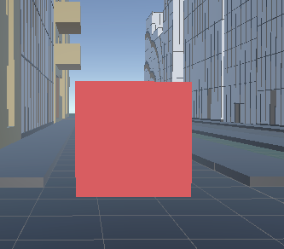

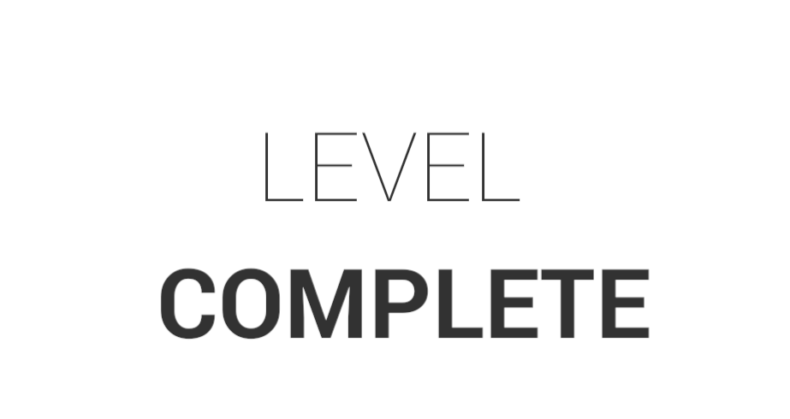

**Timer**

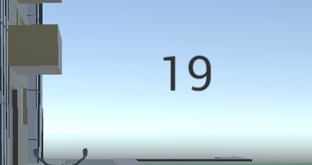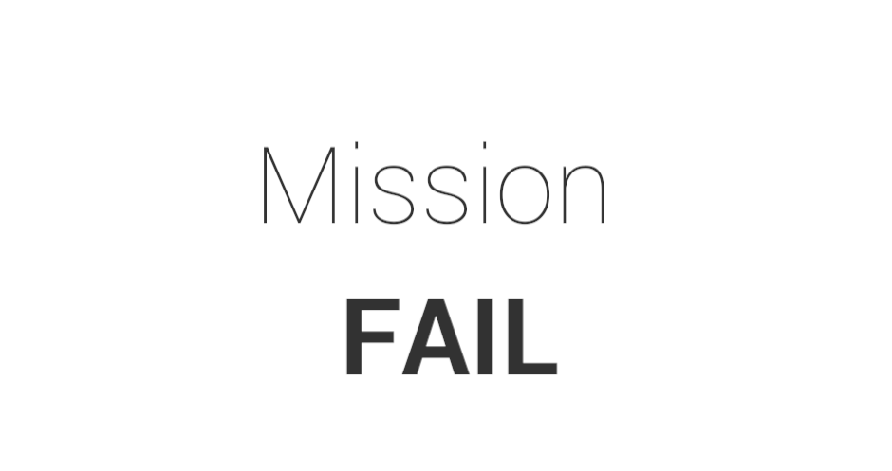

**Bicycle selection**

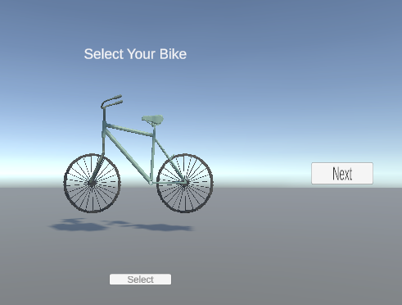

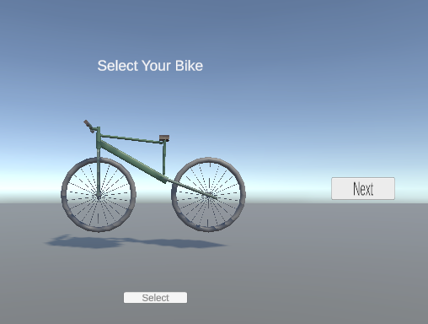

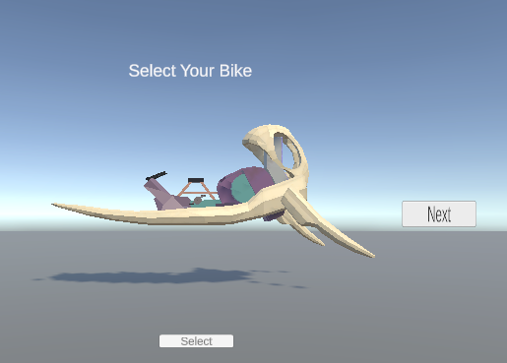

**Map Selection**

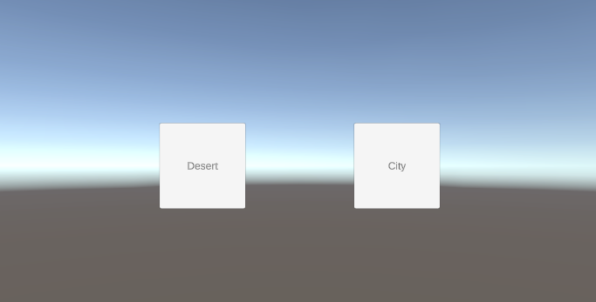

**City Map**

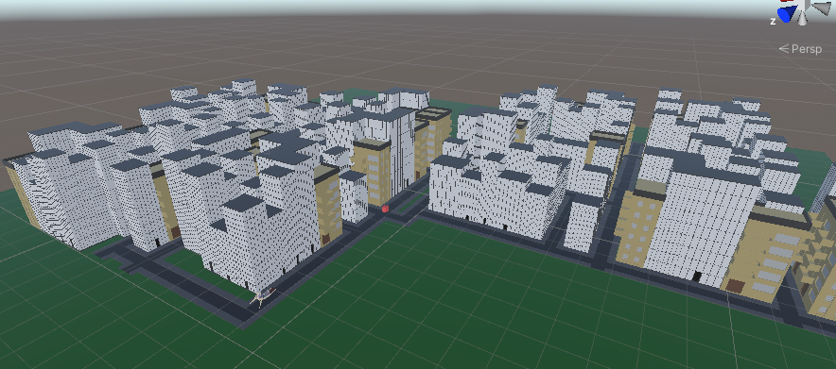

**3D assets**

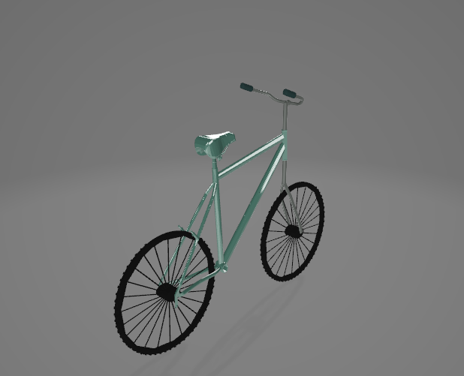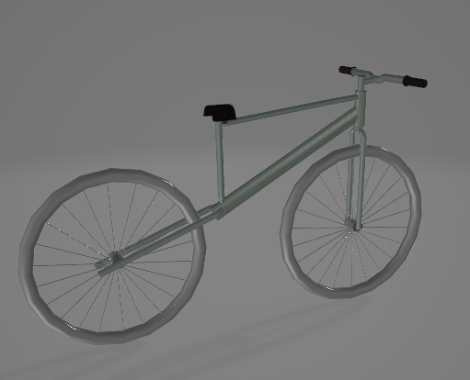

# **10. Content Contribution**

| Name | Content |
| --- | --- |
| Steven Makris | 1,2,3,4,5,8.2(blender,Maya), 9 |
| Daniel Isla | 8(UML, Unity, Draw.io, Github, figma) |
| Hilal Irshad | Section 6, (unity and programming) |
| Nathan | 7 |